The Discovery of the Americas project in Second Life

The Discovery of the Americas project in Second Life has as main aim the incorporation in Second Life of social media driven material – in the form of personal records (images, voice, text). An online platform where files with a limited size can be uploaded feeds the SL environment in a number of ways (data repository and polls) but off-world.

For our use of historical maps we will draw inspiration from David Rumsey’s SL sim on historical maps. However, unlike the maps that are part of Rumsey’s collection (dating from the 18th and 19th centuries), those pertinent to the Discovery of the Americas project have very little in common with the real places they depict.

1st module:
Spherical models
We will work with 2 types of maps:
Spherical – internal
The map “lines” a sphere so that the user can sit inside and experience it from any angle.
Spherical – external
The map wraps a sphere so that it can be seen from the exterior.

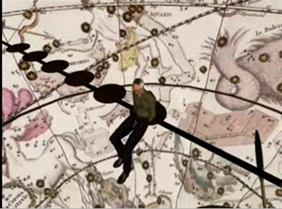 | 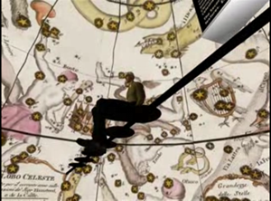

Source: Screenshot taken at David Rumsey’s sim.

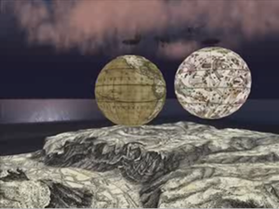
Source: Screenshot taken at David Rumsey’s sim.

2nd module:
Flat historical map with touchable objects.

Several large flat historical maps represent Columbus’ 4 travels. These maps are in a scale such that an avatar can walk along these routes and touch objects in his/her path. Colors give away the type of media (text, audio, images).
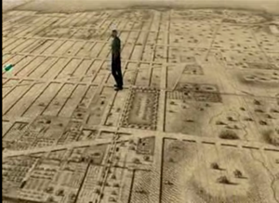
[

[This map is just a representation of the scale that the historical map could have in relation to an avatar].

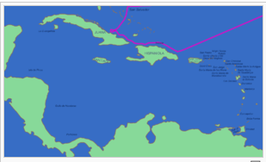 | 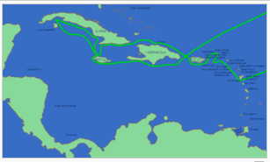
1st travel 2nd travel

At important markers of his travels, there will be 3D objects (arc or similar ‘file’ device) . This device contains media – text, audio and images can be found, all submitted via an off SL platform.

SL residents or not, any user with access to the Internet can access the online platform (announced in appropriate channels and advertised in SL) and add text, image or audio regarding that landmark.

3rd module:
The social module – (proof of concept)

Online users can use a website (announced in appropriate channels and advertised in SL) to answer a poll that briefly indentifies them as Columbus defenders or critics.
The results of the poll are translated into the environment 24 h intervals. The results of the poll have a visual impact in the sim (not decided yet – display of a type of map; environmental changes) and/or trigger media (music, video) according to the ‘winning’ popular dominant view of the last 24h poll.

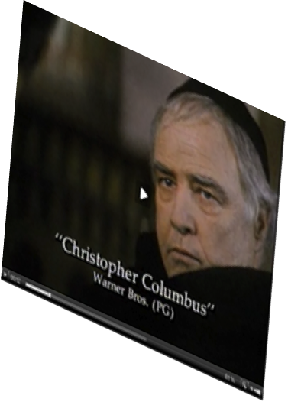
Off-SL poll

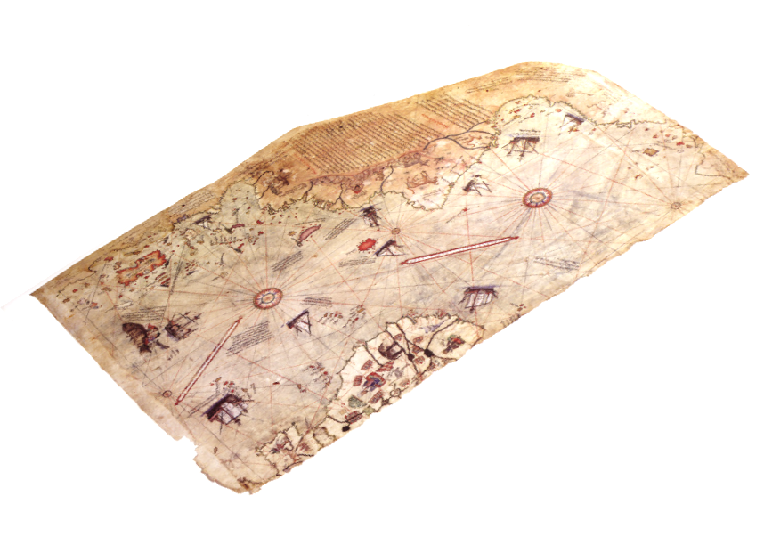

125 192

Results from a poll open on the online platform are fed into the environment every 24h. In this case, the number of Christopher’s critics wins, thus triggering a video (or music) with the same winning critic perspective of Columbus (Image: Snapshot of “Christopher Columbus: the Discovery”)

